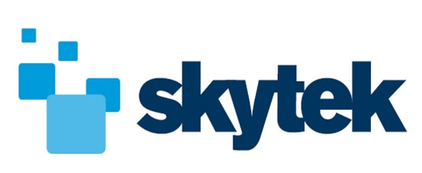

Full Stack Web Developer

Company Introduction
Since our formation in 1997, we have grown our world class software development team to provide solutions that are intelligent, platform-independent and adaptable.

These solutions serve our leading national and international clients including NASA, ESA, the EU, the Irish Naval Service, and many more. Our work has also been recognised by our clients and includes awards from NASA to Skytek personnel for ‘outstanding innovation and development’ for their work on technology for the International Space Station.

Job Description
This role will be based in the Skytek Dublin city centre office working on our core products and major customer solutions. Skytek is looking for a web developer responsible for the development of both server-side logic and front-end elements using the latest web technologies.

The developer is expected to be highly technically proficient in Python, Django, PostgreSQL, HTML/CSS and JavaScript to be able to write, deploy and maintain web applications. The application domain will be Geospatial in nature so a strong knowledge of web-based frameworks such as Leaflet, CesiumJS will be required.

Production experience with Docker and AWS environments is also an advantage.

The role will also involve liaising with customer representatives for product demonstrations and ongoing requirements capture and product definition so excellent communication and interpersonal skills are required.

Responsibilities
- Work in Skytek Dublin office to developing new Geospatial web applications
- Develop and support current Geospatial web applications for key Skytek clients.
- Work directly with the customer on future requirements.
- Based on requirements implement, build and maintain web applications.
- Collaborate with current development team

Skills and Qualifications

- BSc in Computer Science (or equivalent)
- 3 years’ experience in web application product development
- Experience developing with Python, Django, PostgreSQL
- Experience developing with JavaScript, HTML5, DOM, CSS
- Experience using JSON, XML, AJAX and jQuery
- Knowledge and preferred experience with Leaflet, CesiumJS, GIS frameworks
- Knowledge of Docker, AWS
- Ability to communicate clearly with customers
- Travel to customer locations outside Ireland for meetings/presentations

Desirable

- Viewable examples of previous work
- Experience with Agile toolsets, i.e. JIRA and Confluence
- Knowledge of big data concept and open source frameworks
- Use of automated build process tools, version control systems, REST APIs

